Japan Festival 2014 (Embassy of Japan)

Oshi-zushi (Pressed Sushi) &

Cucumber Sunomono (Vinegared Cucumber Salad)

Sushi Rice (for 4-6 persons)

* 4 cups of short-grain rice *1cup=200ml 1. Cook the rice. (Optional: cook it with a piece
* Sushi vinegar (mix a, b & c) of kelp for deeper flavor.)

1. 1/2 cup of rice vinegar 2. Spread the cooked rice on a wooden tub (or a
2. 4 table-spoons of sugar bowl) and sprinkle sushi vinegar over the rice
3. 1 tea-spoon of salt while it’s hot.

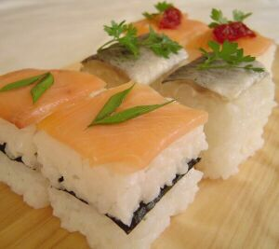

3. Mix the rice and sushi vinegar thoroughly.

4. Covering the tub with a wet cloth will keep the

rice from getting dry.

Oshizushi (Pressed Sushi) (http://eastsearoad.com/Oshizushi_Stepbystep.htm)

* Sushi rice
* Topping (Smoked salmon, shrimp etc.)

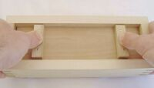4. Place damp lid on top of the sushi rice. Press firmly and evenly to compress rice while holding the sides of the box.

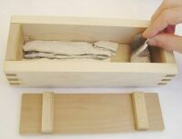2. Place the topping in the base of the box, presentation side down. TIP: If you are using a particularly delicate topping, the box can be lined with cling film first to make removal easier.

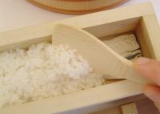

3. Cover topping with prepared sushi rice. Use dampened fingers to even out rice, pressing gently to make sure there are no gaps which can form a weak spot after pressing.

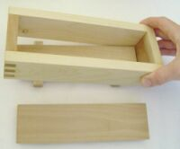

1. Wet the mould thoroughly to ensure sushi rice does not stick to the box. Place the box on top of the base. (the base has feet which protrude from the sides)

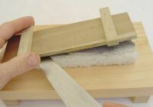

9. Gently ease the base away from the topping with a thin bladed knife.

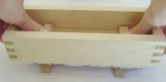

6. Continue to press gently on the lid to keep the base down, while slowly lifting the box away from the sushi rice.

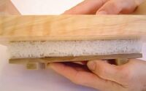

8. Flip the pressed sushi log onto a plate or board so that the topping, still covered with the box base, will be on top.

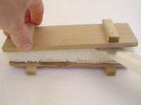7. Gently ease the lid away from the sushi rice with a thin-bladed knife.

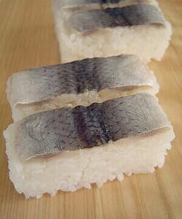

10. Slice pressed sushi log into pieces and serve in pairs.

Cucumber Sunomono (Vinegared Cucumber Salad)

* Japanese Cucumber
* Dry Wakame (Seaweed)

1. Cucumber: Sprinkle salt and roll on a board. Rinse in water and cut into thin slices. Soak in salted water until soft. Wring out water.
2. Wakame: Soak in water for few minutes.
3. Combine the ingredients of the sanbai-zu and mix well. Chiill in redrigerator together with cucumber and wakame.

* Sanbai-zu (Vinegar dressing) Mix a to d.

1. Vinegar 1 1/2 Tbsp
2. Sugar 1/2 Tbsp
3. Light soy sauce 1 Tbsp
4. Dashi stock 1 1/2 Tbsp



Jabara-giri (Snake cuts)

1. Make thin slices diagonally as deep as 2/3. Turnover and do the same on the other side.
2. Soak in salted water until soft.
3. Tear into bite-sized pieces. Squeeze the water out.

 

Gari (Pickled Ginger)

* Ginger 500g (It is best to use fresh young ginger.)
* Rice vinegar 400cc
* Sugar 150g

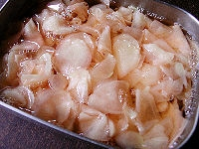

4. After the ginger is cooled down, put them in a container or a jar and pour over the amazu. Mix well and keep it in a refrigerator for half a day then it is ready to be served.

* Water 120cc
* Salt 1 Tbsp

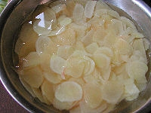

1. Peel and slice the

ginger and soak them in water for 30 min.

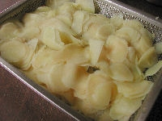

3. Bring the water to a boil in a pan and put the ginger in, then drain the water.

1. Prepar Amazu

(Sweet vinegar). Put vinegar, sugar and water in a pan and bring to a boil. Cool it down and keep it in a refrigerator.